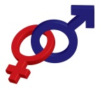 Library Resources for Women & Gender Studies

WGST 200D Darby Lewes August 26, 2012

When in doubt, start at the SUBJECT LINKS on the library webpage!

DATABASES
- Snowden Super Search
  - Google for the library. Searches books, articles, e-books, and more simultaneously
  - Found on main library page
- SocINDEX
  - EBSCO database with a variety of resources on Social Sciences

WEBSITES
- Association of College & Research Libraries(ACRL) Women & Gender Studies Section: http://www.libr.org/wgss/wgsslinks/index.html
- International Institute of Social History WWW Virtual Library Women’s History: http://www.iisg.nl/w3vlwomenshistory/index.html
- National Archives: Women: http://www.archives.gov/research/alic/reference/womens-history.html

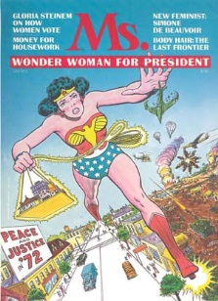
PERIODICALS
- Search A-Z List on library main page
  - Click the “Subjects” tab.
  - Select “Social Science” from the drop down menu.
  - Scroll down to “The Family. Marriage. Women” to browse titles.
- Print items are located on 1st floor & 2nd floor in alphabetical order

REFERENCE MATERIALS
- Great for sifting through ideas & topics
- 1st floor: Call #s typically start with HQ
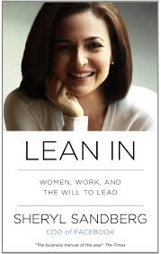
BOOKS
- Search the library catalog using specific terminology: women, gender, feminism
- Many e-books available
- 3rd floor: call# HQ
- Others may be found within major disciplines
  - Example search: women and business = call# HD

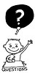

Librarian: Jessica Oberlin
oberlin@lycoming.edu
X4352

All images are from creative commons.org

